Broken access control

**Lab: Unprotected admin functionality**

Problem: This lab has an unprotected admin panel.

Goal: Solve the lab by deleting the user carlos.

Solution:

2-

3-

**Lab: Unprotected admin functionality with unpredictable URL**

Problem: This lab has an unprotected admin panel. It's located at an unpredictable location, but the location is disclosed somewhere in the application.

Goal:  by accessing the admin panel, and using it to delete the user carlos.

Solution:

2-

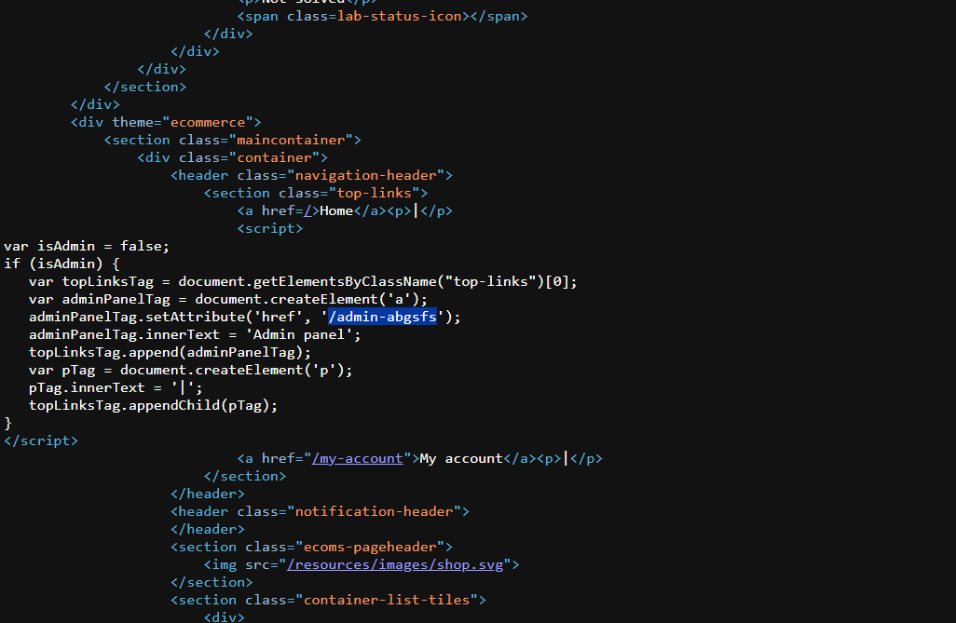

3-

**Lab: User role controlled by request parameter**

Problem: This lab has an admin panel at /admin, which identifies administrators using a forgeable cookie

Goal: Solve the lab by accessing the admin panel and using it to delete the user carlos.

Solution:

1-

2-

3-

4-

